WEST LINDSEY  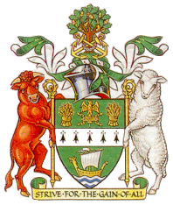  DISTRICT COUNCIL  CHAIRMAN OF THE COUNCIL  Councillor Angela Lawrence | GUILDHALL  MARSHALL’S YARD  GAINSBOROUGH  LINCOLNSHIRE  DN21 2NA  TEL: (01427) 676596  FAX: (01427) 675171

9th March 2016

Dear Mrs Townsend

Re: ‘Clean for the Queen’

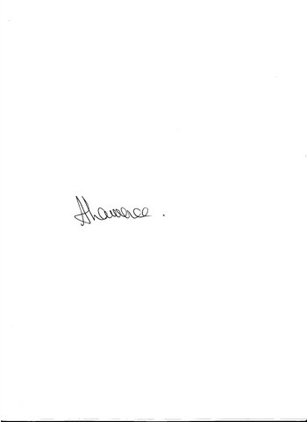
I felt I must write to congratulate you and your fellow residents of Walesby on your ‘Clean for the Queen’ event held on Saturday 20th February.

On reading about the success of the day and the number of volunteers who willingly supported your litter pick in so many different ways – advertising, providing refreshments, collecting the bags etc., etc., I cannot help but be overwhelmed and impressed by the community spirit in Walesby.

To organise and do something like this once is an achievement but to do this each year shows the amazing dedication and passion of all involved in taking care of, and improving, their local communities, something the District Council wholeheartedly supports and encourages.

I would be most grateful if you could pass on my congratulations to everyone involved and also my sincere thanks to them for helping to make West Lindsey a better place to live, work and visit.

Yours sincerely

Councillor Angela Lawrence
Chairman of West Lindsey District Council

