**St Marys Church centenary event – 6th June 2013**

The weather was kind to us and we were blessed with a lovely warm day with plenty of sunshine. By 11.00 am there was a steady stream of guests to the church including our guest of honour Vice Admiral Sir Timothy Laurence. He is the great grandson of the Reverend Perceval Laurence, the founder of St Mary’s church. Sir Timothy was joined by other members of the Laurence family from all over the country and even some from the USA. By 11.30 am the church was full to capacity with a congregation over 120. John Carr led the short celebration service which included a short talk by Peter Starling on the history of the church in Walesby.

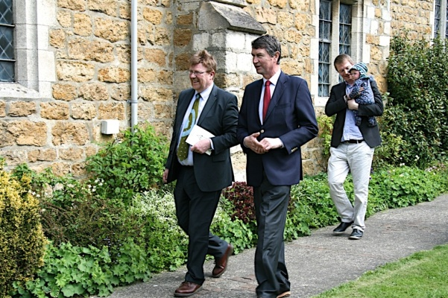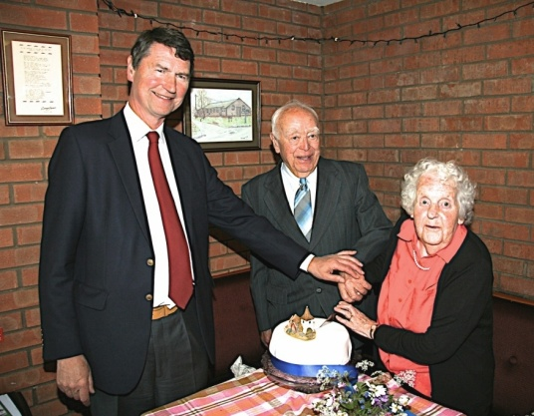

After the service, the guests retired to the village hall for a splendid buffet lunch including a special centenary cake made by Di Newton. Mary and Artie Hawbrook were awarded the privilege of cutting the cake kindly assisted by Sir Timothy. St Mary’s centenary was also celebrated with the publication of Peter Starling’s book, ‘Walesby – A Lincolnshire Village History’. Sir Timothy officiated at the launch and praised the quality of writing and broad scope of the book.

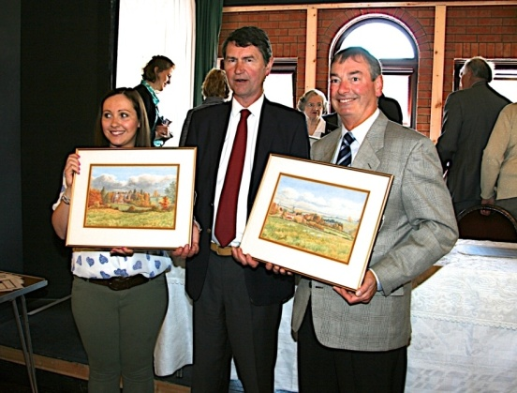

After the book launch Sir Timothy presented Peter with a water colour painting of Walesby that had been in the Laurence family for nearly 100 years. The water colour was one of two paintings and the second was given to Anouska Peckett who lives in the Laurence’s ancestral home, Walesby Hall. Finally, John Carr then presented the Laurence family with five copies of Peter’s book.

Paula Starling